Devin Hardy

MAXimum Wellness

Travel

Table of Contents

Website Description & Purpose 2

Stakeholders & Audience 2

Stakeholders 2

Audience 3

Sitemap 3

Wireframe 4

Live Site & Validation 7

Accessibility 10

References 11

# **Website Description & Purpose**

MAXimum WELLness Travel is here to help give ideas for New Year’s or Spring Break travel plans. Improve your wellness with our focus on rest, relaxation, food, adventure, and exploration.

The purpose of the website is to provide information about great vacations spots for trips during New Year’s or Spring Break. The information will be about great locations at the destination such as resorts, restaurants, and other great locations to relax or explore.

The site will provide spots for a quick retreat for New Year’s and a week long get away for Spring Break. The New Year’s plans will focus on rest and relaxation to revamp for the new year. The Spring Break plans are focused on the adventure aspects of wellness due to most plans being weeklong.

# **Stakeholders & Audience**

The stakeholders are affected by what is decided and shown on the website. Those that are affected are the government, suppliers, and domestic airlines of the listed destinations and some additional stakeholders are employees and the readers.

The audience will be families, couples, or even single individuals as the message they will get is great locations for a vacation.

## **2.1 Stakeholders**

As mentioned before the stakeholders of the site are government, suppliers, and domestic airlines of the listed destinations and some additional stakeholders are employees and the readers. The destinations are affected as they will receive more tourism from being shared as a great vacation location on the website. The employees are affected as they can receive work by posting more information about vacations destinations. The last stakeholder is the reader as they can reflect their own plans based on what is shared on the website.

## **2.2 Audience**

The audience as mentioned before will be families, couples, or even single individuals. The demographic from the audience is roughly split in half for the gender distribution. The age distribution would be spread across the board but those who are 25-34 years old have the highest chance of looking at the sight.

# **Sitemap**

So far, the website will have 3 pages it will have a home page that connects to the New Year plans and the Spring Break plans like figure 3.1 shows. So far, the site is very simple but has plenty of potential to be upgraded further.

Figure 3.1 (Sitemap)

# **Wireframe**

The website will attempt to follow the wireframes that will be displayed in figures 4.1-3. Figure 4.1 is a wireframe based on the home site that will describe what the business is about. Figure 4.2 will hold some information on plans for a trip for New Year’s. And lastly figure 4.3 will display the site for info on what the Spring Break plans should look like.

Figure 4.1 (Home)

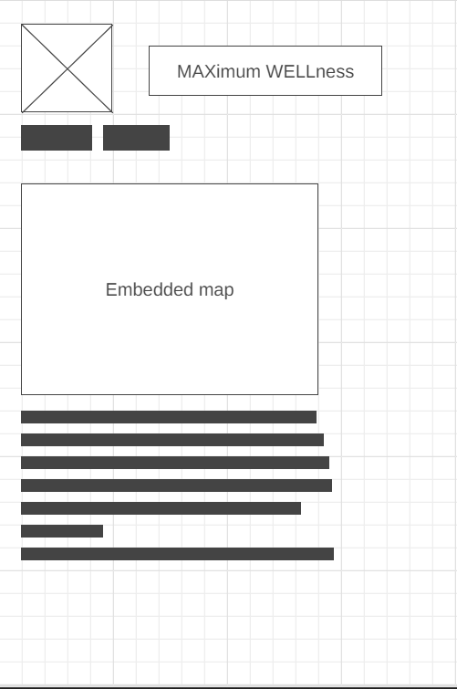

Figure 4.2 (New Year)

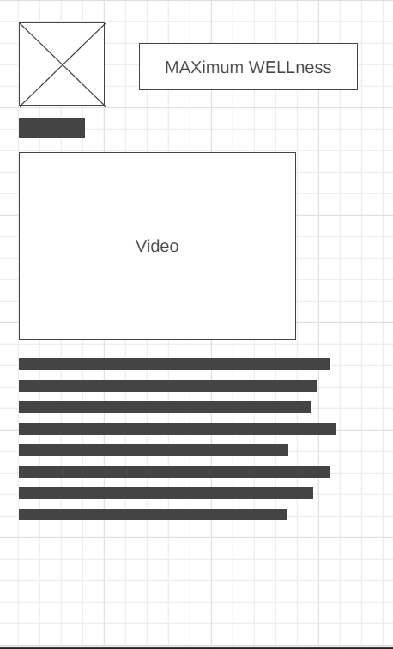

Figure 4.3 (Spring Break)

# **Live Site & Validation**

For this section it is VERY important for you to be sure that you fully understand how to document your Figures in the report because here you will have a minimum of 4, but you may have up to 2 times the number of pages that you create for the site.

For each page that you create you will have to provide a screen shot of your site live on the server, and also a screenshot showing that your HTML page validated. You may end up with something like the following. I have also centered the image and the caption on the page, this is my personal preference to do.

## **5.1 Live Site**

Figure 5.1.1 – 5.1.3 show that the website is currently live on the web and can be accessed. Figure 5.1.1 shows the home page of the website that links to everything. Figure 5.1.2 displays the New Years plans and Figure 5.1.3 shows the Spring Break plans.

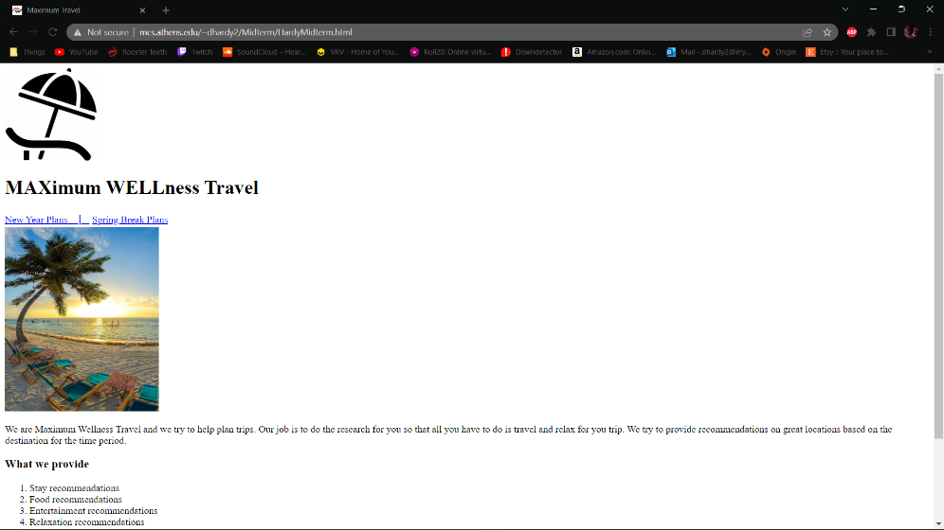

Figure 5.1.1 (Home Site)

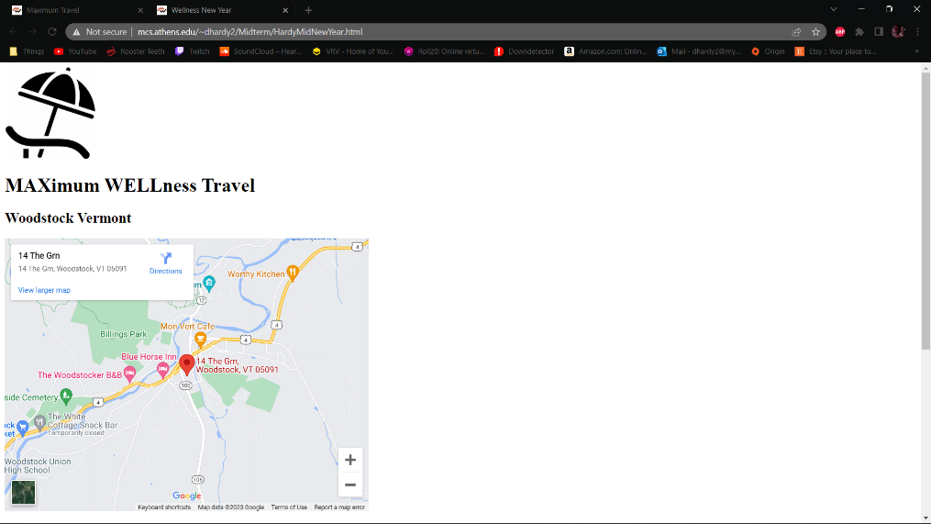

Figure 5.1.2 (New Year Site)

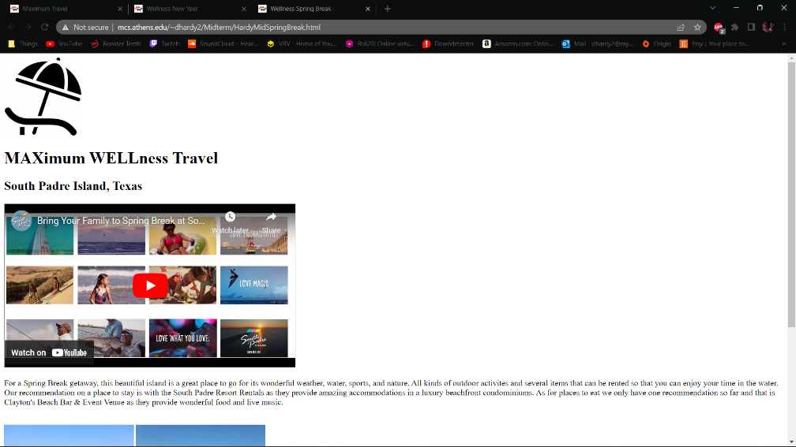

Figure 5.1.3 (Spring Break Site)

## **5.2 Validation**

The Figures 5.2.1-3 all show that there are no errors or warning for the 3 live websites and that they are validated. All three sites have no issues in the code and can be displayed when searching for them.

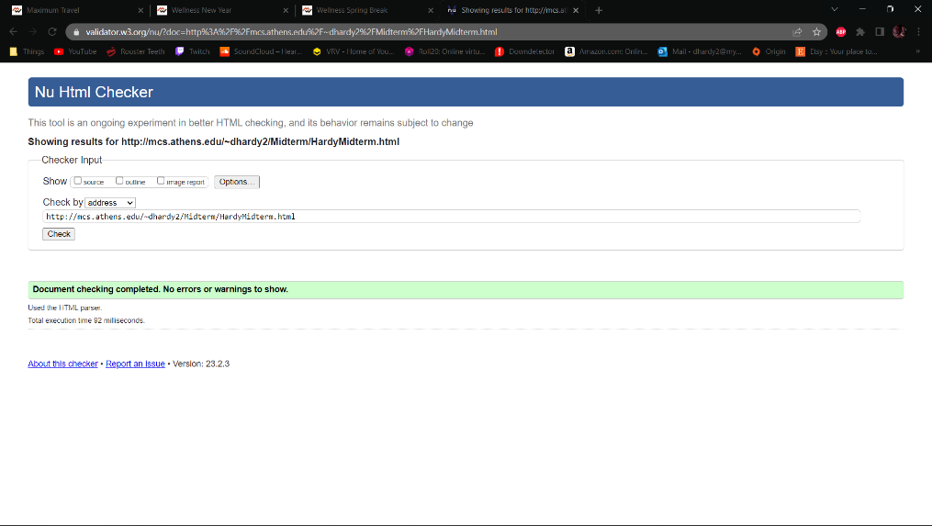

Figure 5.2.1 Home Validation

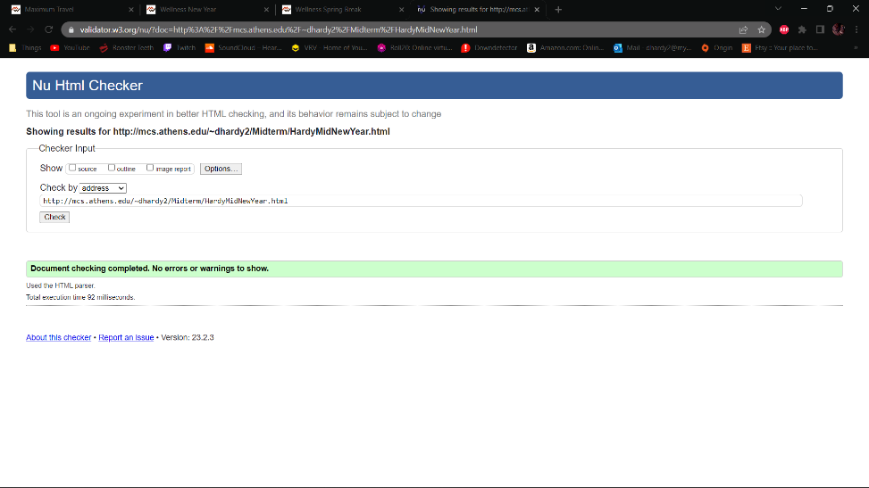

Figure 5.2.2 New Year Validation

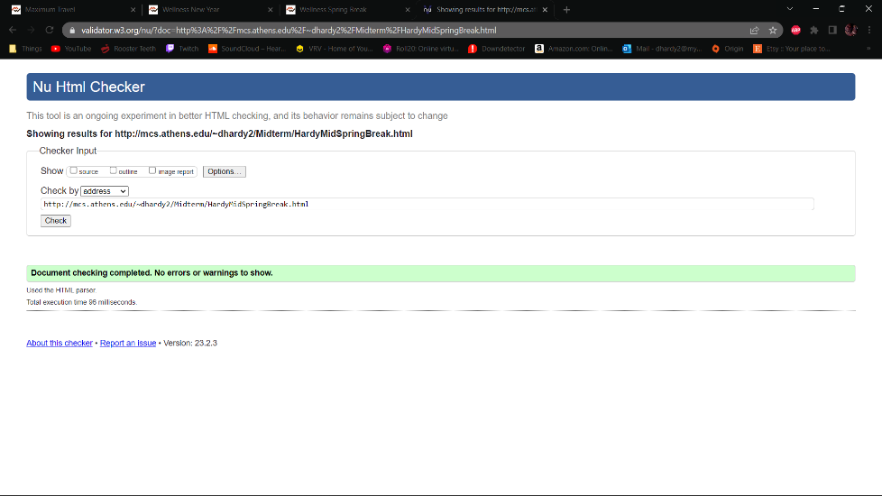

Figure 5.2.3 Spring Break Validation

# **Accessibility**

There is partial accessibility to the website as there are a few alerts for some of the web pages. For the home page it has only 2 alerts one of the alerts is over using heading level 3 without the levels before it. The other alert is it does like the table and says it can be replaced with other objects or enhanced with CSS code to make it work better. The New Year site has no alerts and is accessible without any issues. The Spring Break site has a single alert and it is related to the YouTube video that was embedded in it. This singular alert can be fixed by having the site have generated captions for the video that are equal or better than the quality from YouTube.

# **References**

1. “5 easy steps to creating a sitemap for a website,” *QuickSprout*, 07-Mar-2022. [Online]. Available: https://www.quicksprout.com/creating-website-sitemap/. [Accessed: 06-Jun-2022].
2. C. Neveu, M. Smith, and S. Last, “3.4 figures and tables,” *Technical Writing Essentials*, 01-Jan-2019. [Online]. Available: https://pressbooks.bccampus.ca/technicalwriting/chapter/figurestables/. [Accessed: 06-Jun-2022].
3. H. Bhasin, “What is the purpose of a website?,” *Marketing91*, 29-Jul-2018. [Online]. Available: https://www.marketing91.com/purpose-of-a-website/. [Accessed: 06-Jun-2022].
4. “IEEE - referencing guide: Citing in the text,” *Help and Support*. [Online]. Available: https://libguides.murdoch.edu.au/ieee/text. [Accessed: 06-Jun-2022].
5. K. LaGreca, “How to identify stakeholders for your website project,” *NP Group*, 14-Jan-2016. [Online]. Available: https://www.npgroup.net/blog/how-to-identify-stakeholders-for-your-website-project/. [Accessed: 06-Jun-2022].
6. M. Keenan, “What is meta description and how to write one (+examples),” *Shopify*, 10-Dec-2021. [Online]. Available: https://www.shopify.com/blog/how-to-write-meta-descriptions. [Accessed: 06-Jun-2022].
7. R. Allabarton, “The Definitive Guide: How To Make Your First Wireframe,” *6 steps to make your first wireframe [how to guide + video]*, 06-Aug-2021. [Online]. Available: https://careerfoundry.com/en/blog/ux-design/how-to-create-your-first-wireframe/. [Accessed: 06-Jun-2022].
8. “Sitemap Online Generator,” *Create your Google Sitemap Online - XML Sitemaps Generator*. [Online]. Available: https://www.xml-sitemaps.com/. [Accessed: 06-Jun-2022].
9. “The Wicked Easy Way to create a table of contents in word,” *LinkedIn*. [Online]. Available: https://www.linkedin.com/business/learning/blog/productivity-tips/the-wicked-easy-way-to-create-a-table-of-contents-in-word. [Accessed: 06-Jun-2022].
10. “Franke rentals,” South Padre Island Convention Center &amp; CVB. [Online]. Available: https://www.sopadre.com/listing/franke-rentals/877/. [Accessed: 21-Feb-2023].
11. P. Doherty, “10 best Spring Break destinations in the U.S.,” Travel + Leisure, 16-Oct-2022. [Online]. Available: https://www.travelandleisure.com/trip-ideas/spring-vacations/best-us-spring-break-destinations. [Accessed: 21-Feb-2023].
12. N. Kliest, “Not in the mood to party this Nye? pay a visit to this tucked-away haven in New York,” The Zoe Report, 26-Nov-2022. [Online]. Available: https://www.thezoereport.com/living/relaxing-new-years-eve-getaways. [Accessed: 21-Feb-2023].
13. “The town,” The Woodstock Inn and Resort. [Online]. Available: https://www.woodstockinn.com/stay/the-town. [Accessed: 21-Feb-2023].
14. “Markup validation service,” *The W3C Markup Validation Service*. [Online]. Available: https://validator.w3.org/. [Accessed: 06-Jun-2022].
15. “Maximum Wellness Travel,” Maximum Travel. [Online]. Available: http://mcs.athens.edu/~dhardy2/Midterm/HardyMidterm.html. [Accessed: 21-Feb-2023].
16. “Home Page Markup validation service,” The W3C Markup Validation Service. [Online]. Available: https://validator.w3.org/nu/?doc=http%3A%2F%2Fmcs.athens.edu%2F%7Edhardy2%2FMidterm%2FHardyMidterm.html. [Accessed: 21-Feb-2023].
17. “New Year Page Markup validation service,” The W3C Markup Validation Service. [Online]. Available: https://validator.w3.org/nu/?doc=http%3A%2F%2Fmcs.athens.edu%2F%7Edhardy2%2FMidterm%2FHardyMidNewYear.html. [Accessed: 21-Feb-2023].
18. “Spring Break Markup validation service,” The W3C Markup Validation Service. [Online]. Available: https://validator.w3.org/nu/?doc=http%3A%2F%2Fmcs.athens.edu%2F%7Edhardy2%2FMidterm%2FHardyMidSpringBreak.html. [Accessed: 21-Feb-2023].